JLPT N5: Let’s Go to Hokkaido!

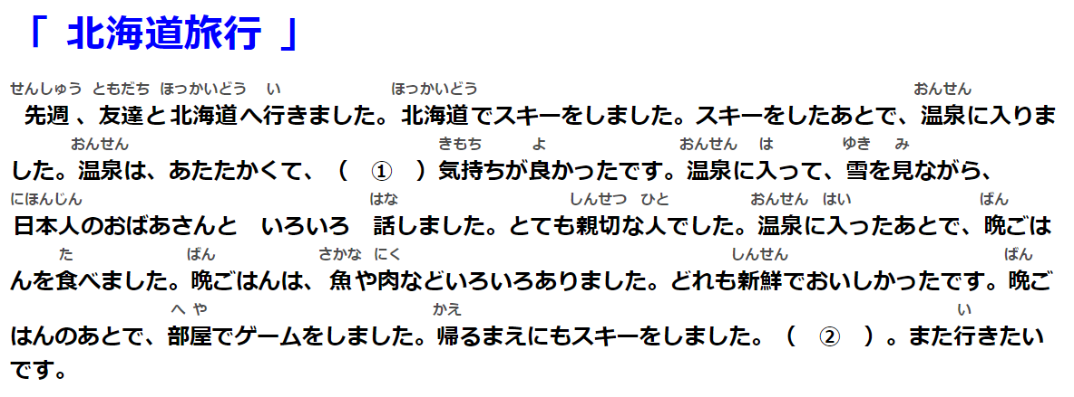
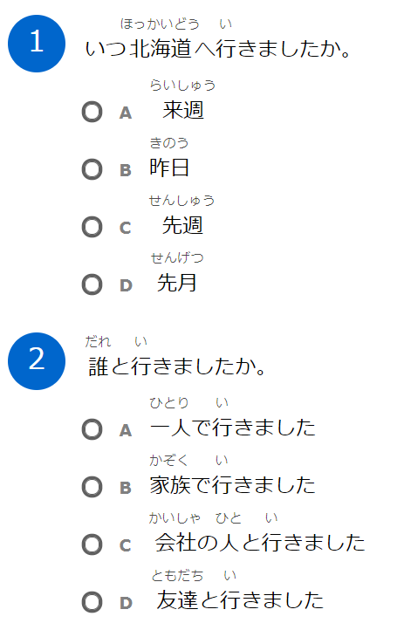

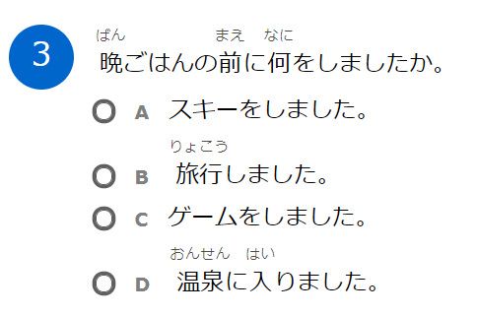
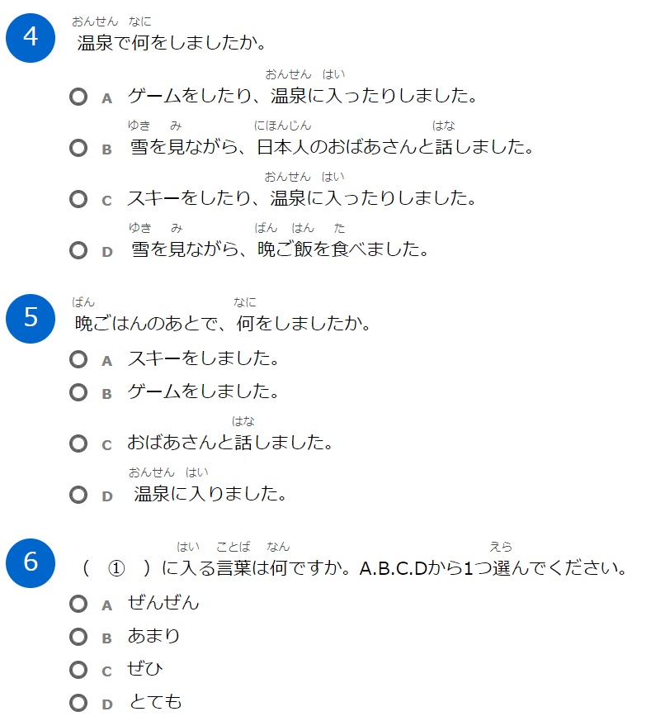
https://www.nihongo-pro.com/quiz/8c3484c611/jlpt-n4-and-n5-reading-comprehension-quiz-lets-go-to-hokkaido

