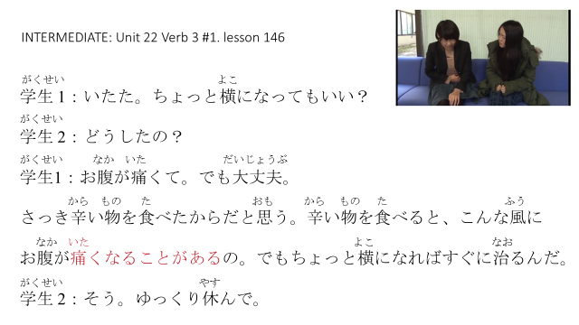

http://www.nihongo123.com/Home/Unit/index/lank_code/2.html

