Sentence Structure in Japanese (The Importance of Particles)

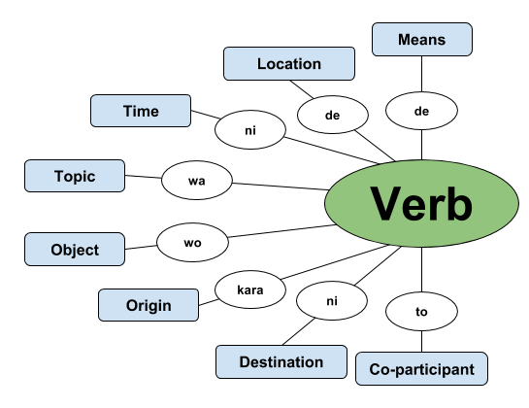
(Source: https://8020japanese.com/japanese-sentence-structure/ )

Note
- The verb is at the end
- The roles of other words are indicated through the use of particles (as above)
- A particle relates to the noun – or noun phrase – before it.
- The topic is usually introduced first, but the remaining information can often be presented in various orders…to emphasise certain details etc.
- The particle “no” indicates possession/belonging e.g. watashi no hon (my book)

Examples:
1. 私 は 犬 と 庭 で 遊びました。
わたし は いぬ と にわ で あそびました。

2. デービッド は 部屋 で アマンダ の 本 を 読みました。
デービッド は へや で アマンダ の ほん を よみました。

Vocabulary
Nouns (meishi) |  |  | Verbs (dōshi)
uchi  ie  kuruma  densha  hikōki  jitensha  basu  neko  inu  ushi  uma  hon  shinbun  zasshi  eiga  tabemono nomimono  eki  kōen  toshokan  daigaku  heya  daidokoro  niwa  tomodachi |  |  | ikimasu  kimasu  kaerimasu  yomimasu  mimasu  nomimasu  tabemasu  kaimasu  hanashimasu  asobimasu  arukimasu  nemasu  okimasu  benkyō shimasu,  renshū shimasu  sōji shimasu  sentaku shimasu  undō shimasu
 |  |  | Adjectives (keiyōshi)
akai
aoi
shiroi
kuroi
takai
yasui
hikui
atarashii
furui
hayai
osoi
oishii
mazui
omoshiroi

