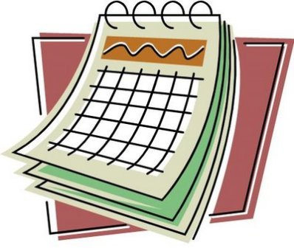
Months, Days and Times

Months (selected)
一月 | いちがつ | ichigatsu | January
二月 | にがつ | nigatsu | February
三月 | さんがつ | sangatsu | March
四月 | しがつ | shigatsu | April
七月 | しちがつ | shichigatsu | July
九月 | くがつ | kugatsu | September
十一月 | じゅういちがつ | jūichigatsu | November

Durations: -kagetsu e.g. ikkagetsu (one month), yon-kagetsu (four), nana-kagetsu (seven)

Days of the Week
日曜日 | にちようび |  | Sunday
月曜日 | げつようび |  | Monday
火曜日 | かようび |  | Tuesday
水曜日 | すいようび |  | Wednesday
木曜日 | もくようび |  | Thursday
金曜日 | きんようび |  | Friday
土曜日 | どようび |  | Saturday

Times
○○ 時 ○○ 分
○○ ji ○○ fun/pun
-- hour -- minute(s)

Number | Hour(s) |  | Minutes(s)
1 | 一時 | ichi ji | 一分 | ippun
2 | 二時 | ni ji | 二分 | ni fun
3 | 三時 | san ji | 三分 | san pun
4 | 四時 | yo ji | 四分 | yon pun
5 | 五時 | go ji | 五分 | go fun
6 | 六時 | roku ji | 六分 | roppun
7 | 七時 | shichi ji | 七分 | nana fun
8 | 八時 | hachi ji | 八分 | happun
9 | 九時 | ku ji | 九分 | kyū fun
10 | 十時 | jū ji | 十分 | juppun
11 | 十一時 | jū ichi ji | 十一分 | jū ippun
12 | 十二時 | jū ni ji | 十二分 | jū ni fun
23 | - | - | 二十三分 | nijū san pun

Related words:
何時 nan ji What time?
半 han half past
丁度 chōdo precisely, exactly
ごろ goro about
時間 jikan time
午前 gozen a.m.
午後 gogo p.m.
前 mae before the hour

