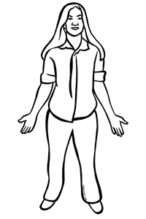
Body and Face

Body | 体 | からだ | karada
Head | 頭 | あたま | atama
Arm | 腕 | うで | ude
Hand | 手 | て | te
Leg/Foot | 足 | あし | ashi
Finger | 指 | ゆび | yubi

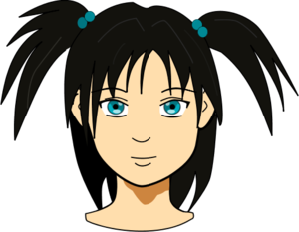

Face | 顔 | かお | kao
Eye | 目 | め | me
Ear | 耳 | みみ | mimi
Nose | 鼻 | はな | hana
Mouth | 口 | くち | kuchi

